Winter 2024

The Ripples
6716 East Side Drive NE, Ste 1 PMB 23
Tacoma, WA 98422
www.dashpoint.org
dpsic07@gmail.com

Happy New Year! Here is hoping 2024 will be a year full of promise!!!

Your Dash Point Social and Improvement Club leadership wishes to focus your attention on a couple of important announcements and pieces of business.

Business:

Your leadership is needed! Please think about this seriously!
Currently, we have two vacant seats on the Board of Trustees – President and Treasurer – and we need volunteers to step forward to help start filling the vacancies. It does not have to be these specific seats but be willing to serve in some capacity as maybe a Trustee to start. The future of DPSIC depends on it. We will have a general meeting in March to elect new officers. That meeting date is to be announced soon. Please consider spending some time supporting our community. It is not a huge amount of time. We put on two events each year, the Dash Point Dash (Fun Run) in June and the Holiday Tree Lighting in December. As a board, we try to meet 3 to 4 times a year.
If you are interested, please contact me, Jean Parker, DPSIC Secretary at 253-266-9628 or jpichaparker@gmail.com.

Membership for 2024 is underway. Fill out the form included on our website and update, mail it in or subscribe on our website at https://dashpoint.org/ .

Announcements:

What you should know…
Water Flushing
Here is a notice from the Tacoma Water Department in case you missed it. Water Flushing is happening now in the Dash Point area. I saw a sign on Eastside Drive; however, it did not include dates. Maybe this notice will be helpful as it has contact information if you need it:
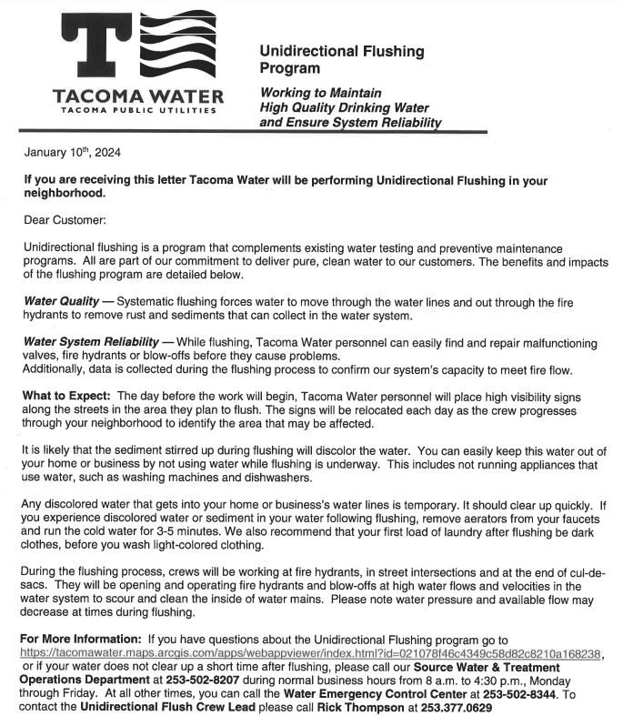

Markham Avenue is now closed for repairs. It started January 23, 2024.
Markham Avenue, the narrow two-lane road to Dash Point Park, is closed for repair. You may have seen the WDOT electronic DETOUR signs on Eastside Drive. The contractor, Northwest Cascade, will be working on a retaining wall. You may have seen the orange cones on the road where the collapsed area has been deteriorating. Detour signs are posted around the area. Access is for local residents ONLY! Please be respectful of this request.

It is unknown how long the closure will be but “on the street advice” from the tradesmen on the site indicate it may be as long as two months. Be prepared for the long haul…
With this in mind, the DETOUR to the beach and local homes are by way of the little street, Arthur, off of Eastside Drive. It is a one lane street. Please be cautious and respectful of the narrow road and your surroundings. Caution is your best defense!!!

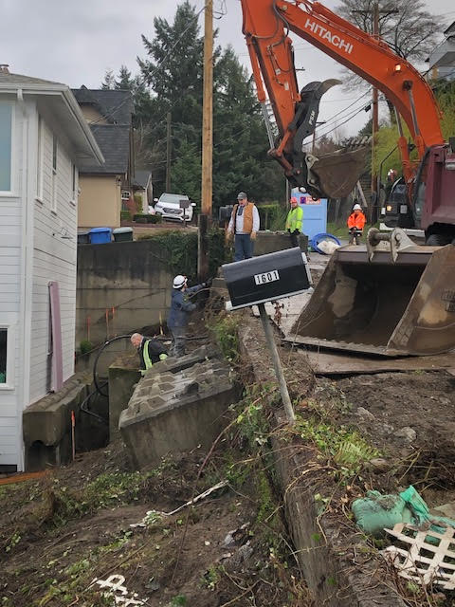

DPSIC Scholarship applications are now available for graduating Seniors!
Any high school age senior in the Dash Point and Browns Point boundaries are eligible to apply for the DPSIC Senior Scholarship.
Please see our website for details : https://dashpoint.org/ Applications are due May 1, 2024.

A Holiday Celebration!
The 2023 Holiday Tree Lighting. What fun!!!
We had great weather; a beautiful tree and a lot of merry makers celebrating the holidays here at Dash Point. Thank you to all who planned, participated made our annual event a great success. The pictures speak for themselves.

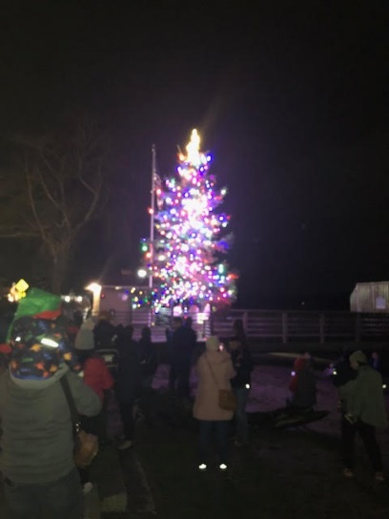

Dash Point Holiday Tree 2023

Okay! The Tree was much more beautiful. We just didn’t get a good shot.
Does anyone else have a pretty picture we can include in the Spring Ripples?
It really was gorgeous --- you just had to be there .

Tom Smith serving up Hot Cocoa and Cider at the DPSIC Holiday Celebration!

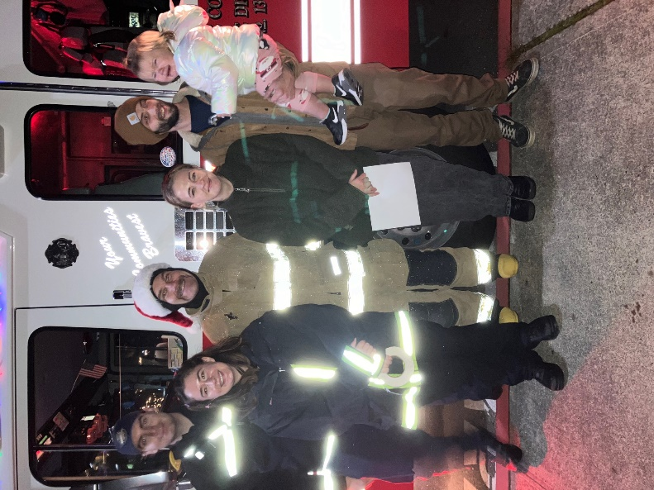

Dash Point Fire Fighter Volunteers and friends celebrating the holidays.

Have a great 2024.

Jean Parker
Ripples Editor and DPSIC Secretary

