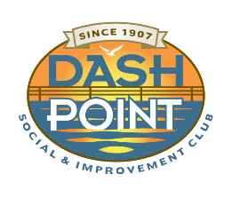
Holiday Updates 2022

The Ripples
6716 East Side Drive NE, Ste 1 PMB 23
Tacoma, WA 98422
www.dashpoint.org
dpsic07@gmail.com
Hello from The Ripples, our Dash Point Social and Improvement Club (DPSIC) newsletter. It is that cheerful time of year to provide updates on the treasured holiday happenings coming up in our Dash Point community. It is a wonderful time to socialize with friends, neighbors and enjoy the merriment and cheer.

The holiday tree went up on the dock this weekend (Saturday, 11-26-2022). Again this year, it is a gorgeous tree, locally grown and donated by one of our DPSIC members. Thank you to our tree donors past and present! Many thanks are also in order to our Browns Point & Dash Point Fire Department - Pierce County Fire District 13 which put up the tree with the help of many volunteers including our “Dash Point Holiday Tree Chief” Tom Smith.

The official lighting of the Dash Point Holiday Tree and festivities will be on
Saturday, December 3, 2022 at 6 p.m. at the Dash Point Park and pier. Included during this event will be:

- Caroling by the Northpoint Cooperative Preschool students
- Holiday music played by our local trumpeters, John Lloyd and Bill Lawson
- Santa Claus will arrive, escorted by the Browns Point & Dash Point Fire Department
- Refreshments, including hot chocolate, cider and cookies will be provided at the beach picnic shelter
- And, the beach bonfire is not certain, but work is being done to hopefully provide that special tradition
- You are also encouraged to please contribute an item or two of non-perishable food that will be delivered to our local United Methodist Church (UMC) food pantry

Save the date! All adults and kids are welcome!
If you have any questions, contact the DPSIC Trustees at our email: dpsic07@gmail.com
Have a wonderful holiday season and see you at the beach!

Jean Parker – Ripples Editor

