Scholarships will be awarded to eligible graduating high school seniors who currently live in the Dash Point or Browns Point communities (see attached eligibility map on page 5).

It is a requirement that the applicant or parent be a current member of the Dash Point Social & Improvement Club. Annual dues are $10 per person. Please apply online for DPSIC membership or download an application form.

Applicants planning to attend a two or four-year university, college, technical or professional school may apply. We encourage students planning enrollment in non-degree, certificate/apprenticeship programs such as skilled trades, construction trades, healthcare, manufacturing, management, sales and merchandizing to apply.

Although the scholarship committee considers an applicant's academic transcript in awarding these scholarships, considerable value is placed on an essay of future educational/life goals, contributions to school, leadership qualities and service to the community.

Again, this year, one scholarship will be awarded with community service as the most important element in memory of Janet Flynn. She was the owner of Janet's Table Supply, a small community store that was located near the old Dash Point School on Eastside Drive.

Applications must include the following:
- Completed online application form along with a cover letter (application forms also available at www.dashpoint.org).
- An essay describing your future educational/life goals and why you have chosen this career path. Please limit your essay to one typed page. Verify your statement with your signature.
- A signed high school transcript from your school's registrar that includes your cumulative grade point average through the first semester of your senior year. Transcript must be sealed and notarized for security purposes.
- A copy of the acceptance letter from your chosen university, college, technical, vocational or professional school.
- Letters of recommendation can be included but are optional. These letters are often sealed for confidentiality.

All applicants will be notified of the scholarship committee's decision prior to graduation.

NAME: | _____________________________________________________________
ADDRESS: | _____________________________________________________________
TELEPHONE: | _____________________________________________________________
EMAIL: | _____________________________________________________________
DPSIC MEMBER NAME: | _____________________________________________________________
APPLICATIONS DUE MAY 1st BY 5:00 PM
Mail or deliver completed application to:
Ms. Kathy Martin
1502 Markham Avenue NE Dash Point, WA 98422
Questions can be answered by calling Ms. Martin at 253-927-6593
Graduation Year .

Please type or print all responses. This form must be accompanied by your one-page essay, your high school grade transcript (9th grade through your first semester in grade 12) and a copy of the acceptance letter from your chosen university, college, technical or professional institution.

Name:________________________________________________________________________
Address:______________________________________________________________________
Community: Dash Point ____ or Browns Point ____
Email:_________________________________________ Phone:_________________________
Intended field of study:__________________________________________________________
High School:___________________________________________________________________
Middle School:_________________________________________________________________
Elementary School:______________________________________________________________
College, university, technical, vocational, professional school planning to attend:_____________
______________________________________________________________________________

Honors and Awards: List below any honors, awards or recognition that you have received.

Honor or Award | Gr. 9 | Gr. 10 | Gr. 11 | Gr. 12 | Organization

Leadership Positions: List elected or appointed positions held in school, community or work activities, including positions in which you were directly responsible for directing or motivating others. For example, student body, club officer, committee chair, team captain, newspaper editor, etc.

Leadership Position | Gr. 9 | Gr. 10 | Gr. 11 | Gr. 12 | Activity or Organization

School Activities: List all activities outside of regular classes in which you have participated during high school. Include clubs, musical groups, athletic teams, etc. List all major accomplishments, if any, in each (such as varsity letter, treasurer, lead role, etc.)

Club, Organization, Team | Gr. 9 | Gr. 10 | Gr. 11 | Gr. 12 | Accomplishments

Community Involvement: List all community activities in which you have participated. These should be activities outside of school credit such as church groups, scouts, 4-H and volunteer groups.

Organization | Gr. 9 | Gr. 10 | Gr. 11 | Gr. 12 | Activity Performed/Length of Service with Contact Person and Phone Number | Total Hours

Work Experience:
Organization | Gr. 9 | Gr. 10 | Gr. 11 | Gr. 12 | Activity Performed/Length of Service with Contact Person and Phone Number

Complete both pages of the application form and return with cover page, essay, transcript and acceptance letter by May 1st to address shown on the application cover page.

Signature: _______________________________________________ Date: _______________________

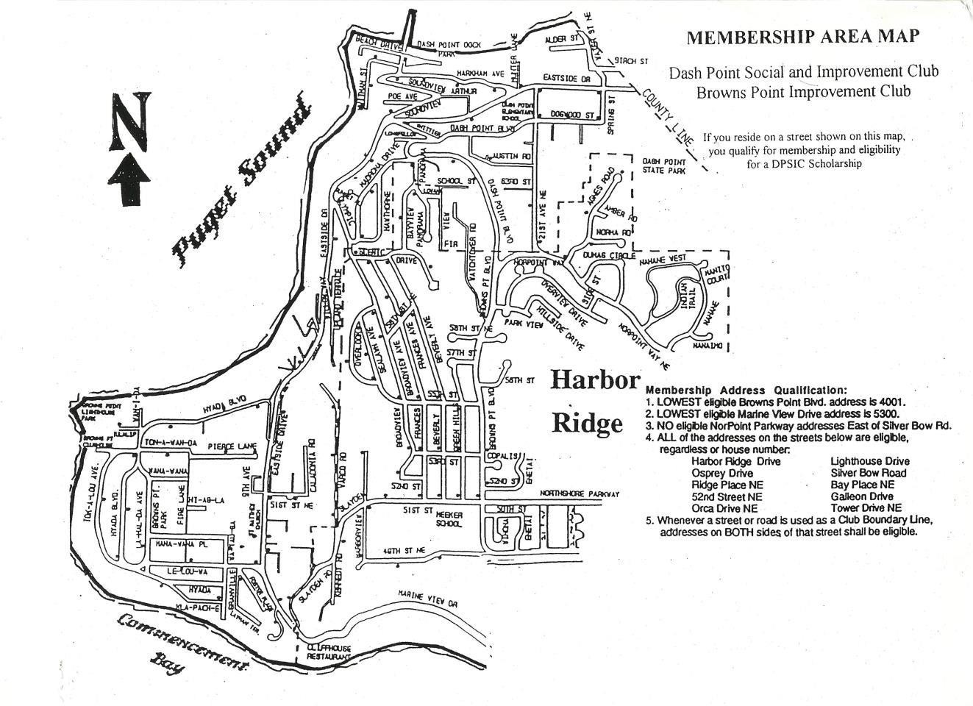

Dash Point Social and Improvement Club – Membership Application or Renewal for 2021

Name:________________________________________________________________________
Address:______________________________________________________________________
City (Dash Point or Browns Point):_________________________________________________
State:________ Zip:________
Email:_________________________________________ Phone:_________________________
Enclose check for $10.00 per person payable to DPSIC

Mail to:

DPSIC
Attention: Membership
6716 East Side Drive NE
Ste 1 PMB23
Tacoma, WA 98422

